**Calligraphy Distinguishing**

**OUTPUT SCREENS:**

1. Output will be a GUI which consists of various buttons representing the various alphabets in dataset so that user will be able to choose the type of alphabet that is need to be recognized by machine.

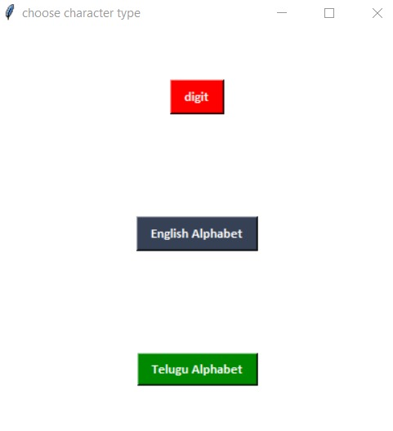

2) Below are the few handwritten alphabets that are stored in data set in the form of pixels

2a) For Alphabets

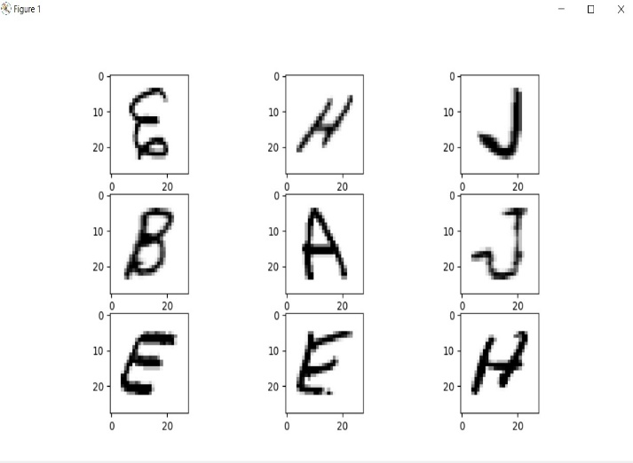

2b) For Digits

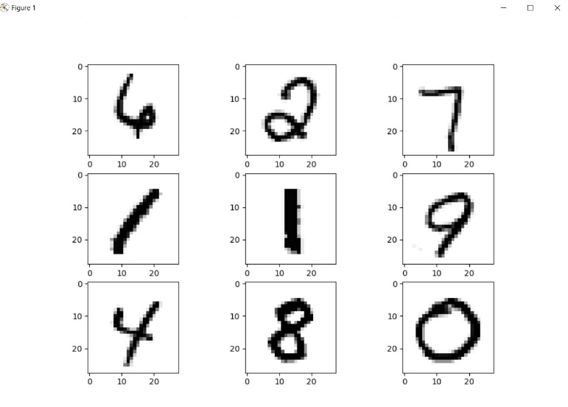

2c) For Telugu Alphabets

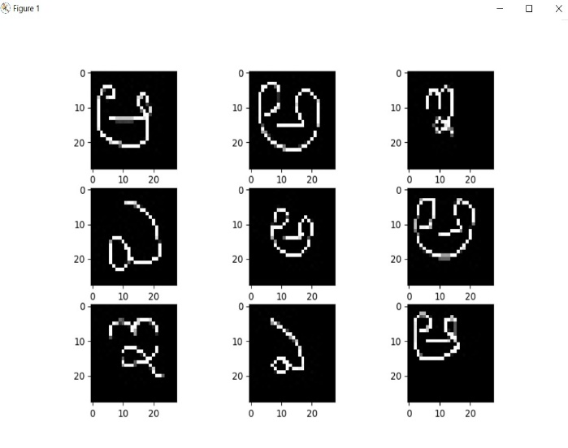

3)User can upload the image either through searching image file in their pc or through taking the picture of handwritten alphabet.

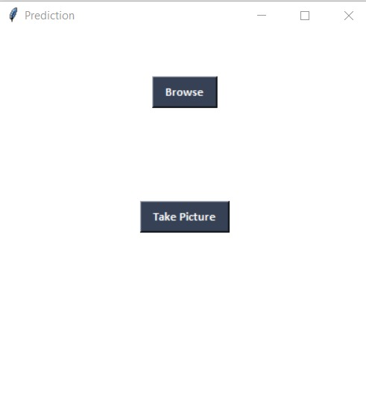

4a)Prediction for Telugu Alphabets

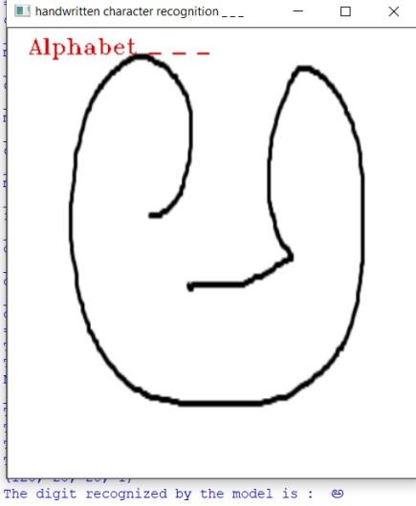

4b)Prediction for Number

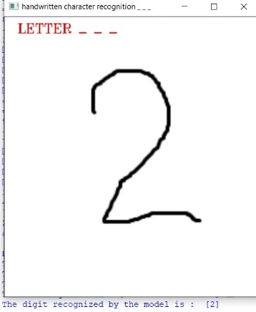

4c)Prediction for English Alphabet

